Getting Started
The FAST software is a web-based application. The general navigational controls in the next three sections will need to be revised. This is just an example for the doc.
Navigation and Keyboard Use 2
Screen Controls 5
Mask Control Parameters 8
How to Use Online Search and Concepts 9

Navigation and Keyboard Use
also see the SnagIt stock stamps
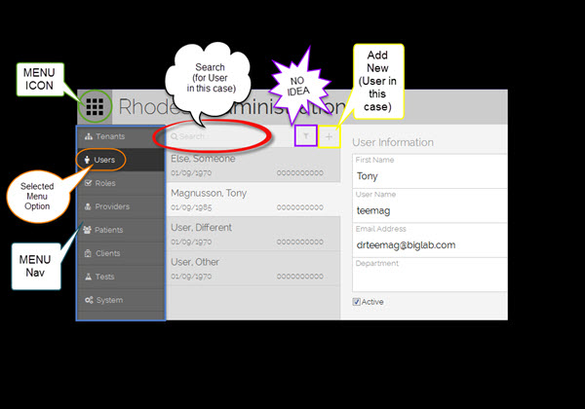

- Arrow buttons - Left and right move cursor within a data field; up and down are non-functional.
- Enter - Moves cursor to the next point of focus, a button or data field.
- Tab - Moves cursor forward to next point of focus, a button or data field.
- Shift-Tab - Moves cursor backward to previous point of focus, a button or data field.
- Backspace - Deletes one character at a time to the left of the cursor.
- Delete - Deletes one character at a time to the right of the cursor.
- End - Moves cursor to end of current data field entry.
- Home - Moves cursor to beginning of current data field entry.
- Page Up / Page Down - Non-functional.
- Hot Keys: Underlined letters in Buttons and Field names allow the User to navigate to that control by pressing the ALT key and the underlined letter at the same time.
- Camera- This button is present on many screen and provides User with ability to take a screen shot of current display.

If you see this icon, , it means to open the link in a new window. In the example below, you may open the FO_LabInfo table in the current window by clicking on the link or in a new window by clicking on the icon,.
See more information on the FO_LabInfo on page Error: Reference source not found table.

Everwhere

Button | Action
Cancel | Click Cancel to exit this screen without saving any changes and return to the previous screen.
Save | Click Save to save all data on this screen and return to the previous screen.

Check box fields are toggles. Click a clear check box to check it. Click a checked box to clear it.

Screen Controls
also see the SnagIt stock stamps
The application uses several types of standard web screen controls. The most common are as follows:

In new SW, find all of these elements, get a graphic and explain how they work.
Including drop-down list, combo box, multi-select combo box
(combo box allows user to enter their own value)
https://www.cs.tut.fi/~jkorpela/forms/combo.html
multiple select combo box: http://www.w3schools.com/tags/att_select_multiple.asp

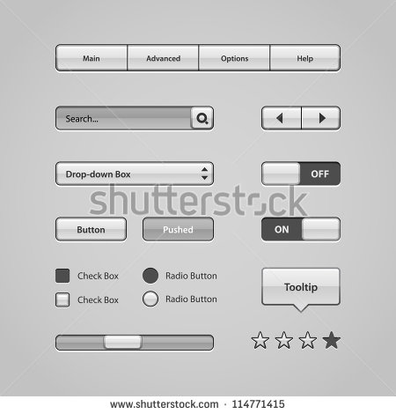

- Buttons
  - Click with the left mouse button to activate.
- Spread Sheets
  - Several screens support spreadsheets that display row and columns of information.
  - Some of these allow the User to sort by column by pressing on the heading.
  - Some allow the User to edit fields in a column.
  - A row generally can be highlighted by clicking on it and un-highlighted by pressing the space bar when highlighted.
- Drop-Down field
  - Allows you to choose one value from a list of values. After selection, that value remains displayed until changed.
  - Display the drop-down list from which to choose by clicking on the XXX arrow at the right of the field.
  - Allow the User to fill a field by using the arrow on the right hand button to pick from a selection.
  - Typically they show many fields but select only using one.
  - Some support hover over to display additional information such as the coded element of a description.
- Combo Box, drop down field
- Entry Field
  - Allows you to enter or edit information.
  - Yellow fields are mandatory.
  - Blue fields are important entry points.
  - The TAB key is used to navigate between fields.
  - Hot keys assigned to fields may also be used to access them.
  - The Mouse may be used to click the cursor in a field.
  - Semicolon is override entry for some mandatory fields so process is not stopped when information is missing. The value is not stored.
- Mask Controls
  - Guide you to properly format the entry for a field.

Mask Control Parameters
Mask Controls support the following parameters.
MASK CODE | DESCRIPTION
 | No mask codes represent the absence of any formatting control
# | For digits 0-9
@ | Allows any text character A-z and space
* | Allows any character
\ | Put in front of a code to actually show the code on the field
Any Other | Becomes part of the display on the field
For example:
Use ##### (five pound signs) to allow up to five numbers to be entered.
Use @@## to allow two letters and two numbers.
Use (###) ###-#### to display 2 parenthesis to create a telephone format.

How to Use Online Search and Concepts
Delete this text and replace it with your own content.

