Administration Tools
The administration section contains information and instructions for system configuration and maintenance.
Many tasks covered in this section must be completed before using the FAST application. They are indicated by a Do First graphic, 1st!.
Other maintenance tasks are on-going as you add new users, patients, or providers to the system.
Some tasks are configurations which may be changed as you change your work processes.

Be sure to read the Getting Started section so that you understand how to navigate the application and how to manage and save data.

Role Maintenance 2
User Maintenance 6

Role Maintenance
This maintenance screen is used to
- create a user role
- edit a role
- deactivate a role without removing it from the system
- delete a role (???), can a role be deleted, how?
You must create a new role and assign one or more permissions to that role before the role can be assigned to a user.
Each record in this table represents a single role. Each role may have one or more permissions assigned to it.
Role data is saved in several database tables. See User Definitions on page Error: Reference source not found for more information on tables, fields and definitions.

Role Maintenance Screen
The Role Maintenance screen provides a way to define roles and attach permissions to those roles.
Notice the Copy Role and Compare Roles links which provide additional functionality.
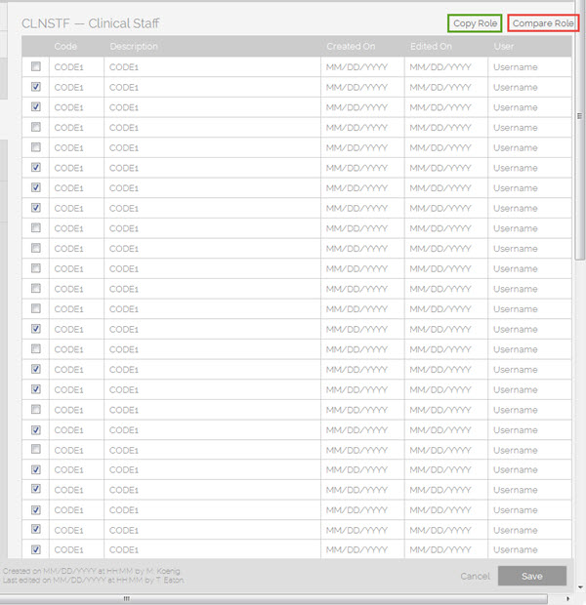

Role Maintenance Screen – Field Notes
Role Maintenance Screen -- Field Notes
Field | Definition and Requirements
>>>>> | GET ACTUAL ROLE Fields for this table.
Last Name | Enter user’s last name.
User Name | Enter a user name for this user.
Timeout (in minutes) | Enter an integer for the number of minutes of inactivity after which the user will automatically be logged out.
Email Address | Enter a valid email address for this user.
Phone Number | Enter user’s phone number. (is there a format mask?)
Department | Enter user’s department (code?).
Manager | Enter user’s manager (code?).
Active check box | Select, or check, this box to activate the user.  Clear, or uncheck, this box to deactivate the user. The user record will remain in the system and can be reactivated at a later time.
Reset Password link | Click this link to reset user’s password.
Application Settings
Orders check box | (some kind of permissions setting?)
Results check box | (some kind of permissions setting?)
Billing check box | (some kind of permissions setting?)

Role Maintenance Screen - Button Actions
Button | Action
Cancel | Click Cancel to exit this screen without saving any changes.
Save | Click Save to save all data on this screen.

User Maintenance
This maintenance screen is used to
- create a new user and assign their initial password and permissions
- edit user permissions
- deactivate a user without removing them from the system
- delete a user (???), can a user be deleted, how?
You must create a new user and assign their permissions before that user can log into the system.
Each record in this table represents a single user. The core component of these entries is the user name and the value must be a unique entry in this table. The user name may be the user’s network ID or an arbitrary name assigned by the administrator. The system is able to automatically check for the network user name that is logged in to the windows session and default it in the user login screen.
An individual may have multiple user records, multiple logins, each with different permissions. For example, you may have a user with an assignment as an administrator and an assignment as an intake clerk .
User data is saved in several database tables. See User Definitions on page Error: Reference source not found for more information on tables, fields and definitions.
User Maintenance Screen
The User Maintenance screen provides a way to enter basic user information such as name, user name and email address, to mark the user as active or inactive, assign permissions and reset the user's password.
Notice the Active check box, the Reset Password link (or button?) and the Application Settings check boxes which assign specific sets of permissions.
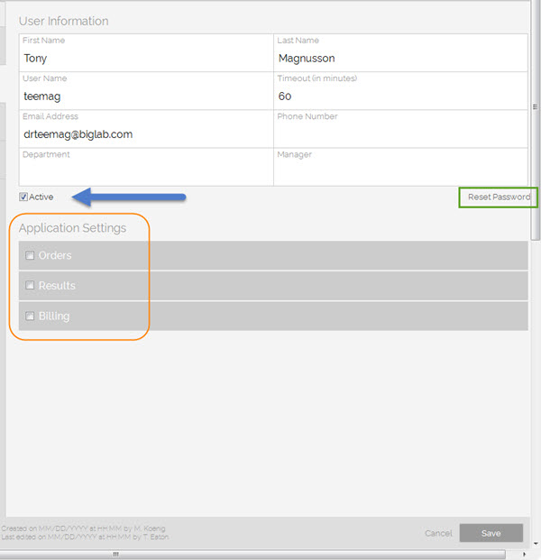
User Maintenance Screen – Field Notes
User Maintenance Screen -- Field Notes
Field | Definition and Requirements
First Name | Enter user’s first name.
Last Name | Enter user’s last name.
User Name | Enter a user name for this user.
Timeout (in minutes) | Enter an integer for the number of minutes of inactivity after which the user will automatically be logged out.
Email Address | Enter a valid email address for this user.
Phone Number | Enter user’s phone number. (is there a format mask?)
Department | Enter user’s department (code?).
Manager | Enter user’s manager (code?).
Active check box | Select, or check, this box to activate the user.  Clear, or uncheck, this box to deactivate the user. The user record will remain in the system and can be reactivated at a later time.
Reset Password link | Click this link to reset user’s password.
Application Settings
Orders check box | (some kind of permissions setting?)
Results check box | (some kind of permissions setting?)
Billing check box | (some kind of permissions setting?)
User Maintenance Screen - Button Actions
Button | Action
Cancel | Click Cancel to exit this screen without saving any changes.
Save | Click Save to save all data on this screen.

