Appendix
The following pages are appendix items.
APPENDIX - Insurance Grouping by User 2
APPENDIX - Medical Necessity, LMRP and ABN Tables Relationship 3
APPENDIX - QA Tables Relationship 4

APPENDIX - Insurance Grouping by User
Relationship between the insurance group and user group for insurance grouping by user.
Every user whose user group defined in the FO_Users.Ins_User_Assignement field matches one of the user groups defined in the FO_Ins.Ins_User_Assignement field may see the insurance code(s) assigned to their user group.
Here are the two tables and their relationship.
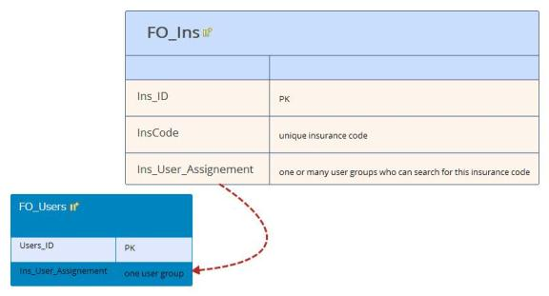

APPENDIX - Medical Necessity, LMRP and ABN Tables Relationship
For the medical necessity, LMRP and ABN rule set.
Here are the tables and their relationships.

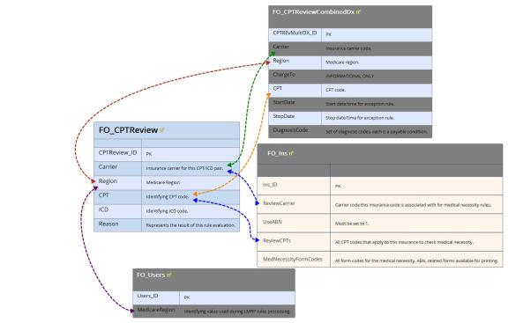

APPENDIX - QA Tables Relationship
RESOE process - some tests need questions and answers
Here are the two tables and their relationship.

